Jak zabranit spusteni vice nez jedne instance programu

**Kodovadlo – bootstrapper:**

private bool CheckMultipleProgramInstances()

{

string applicationName = Assembly.GetExecutingAssembly().FullName;

applicationName = applicationName.Substring(0, applicationName.IndexOf(','));

// Povolit spustene prave 2 instance K2

string procName = Process.GetCurrentProcess().ProcessName;

if (Process.GetProcessesByName(procName).Length > MaximumProgramInstances)

{

MessageBox.Show(string.Format(Localisation.ApplicationIsAlreadyRunning, applicationName),

Localisation.ApplicationIsAlreadyRunningDialogTitle, MessageBoxButton.OK, MessageBoxImage.Warning);

if (m_log.IsWarnEnabled)

m_log.Warn($"More than {MaximumProgramInstances} program instances!");

return false;

}

return true;

}

**Simlog – mutex**

Mam guid definovany v configu. Mutex ho bere jako parametr v konstruktoru. Na zaklade toho, ze si muzu dat do configu kazdeho prostredi unikatni appGuid mi mutex ohlida jen tento proces a proto bude mozne pustit ClickOnce pro kazde prostredi, ale vzdy jen jednu instanci od kazdeho environmentu.

**common.config:**





**ApplicationProperties**

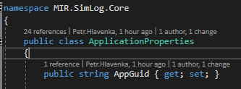

**AppBootstrapper:**



**Inicializace je az v metode Configure, potom co je resolvnuty Castle.Current a nainstalovano z configu:**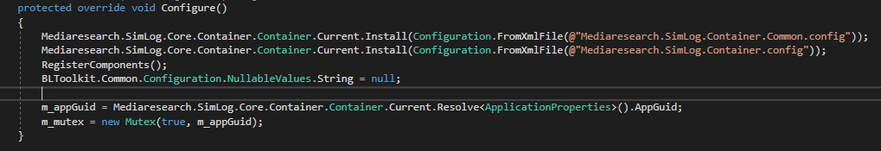

**A samotny mutex:**

